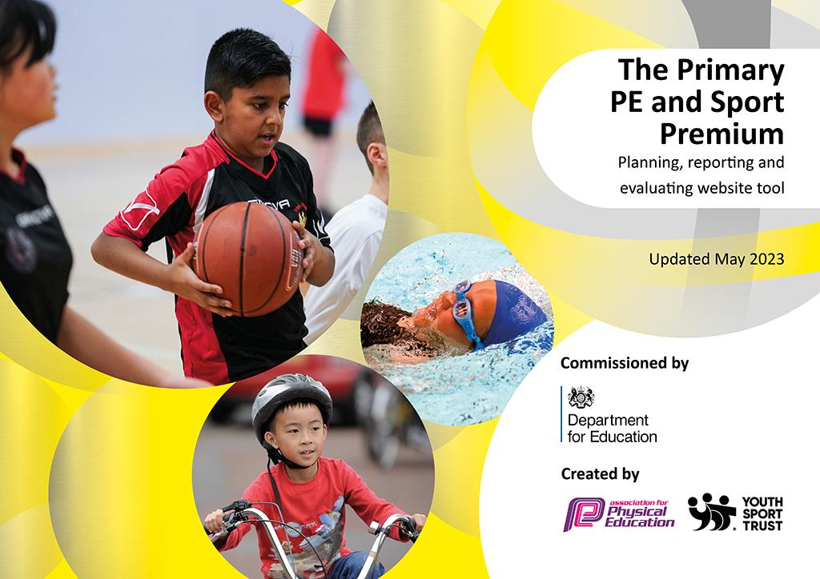
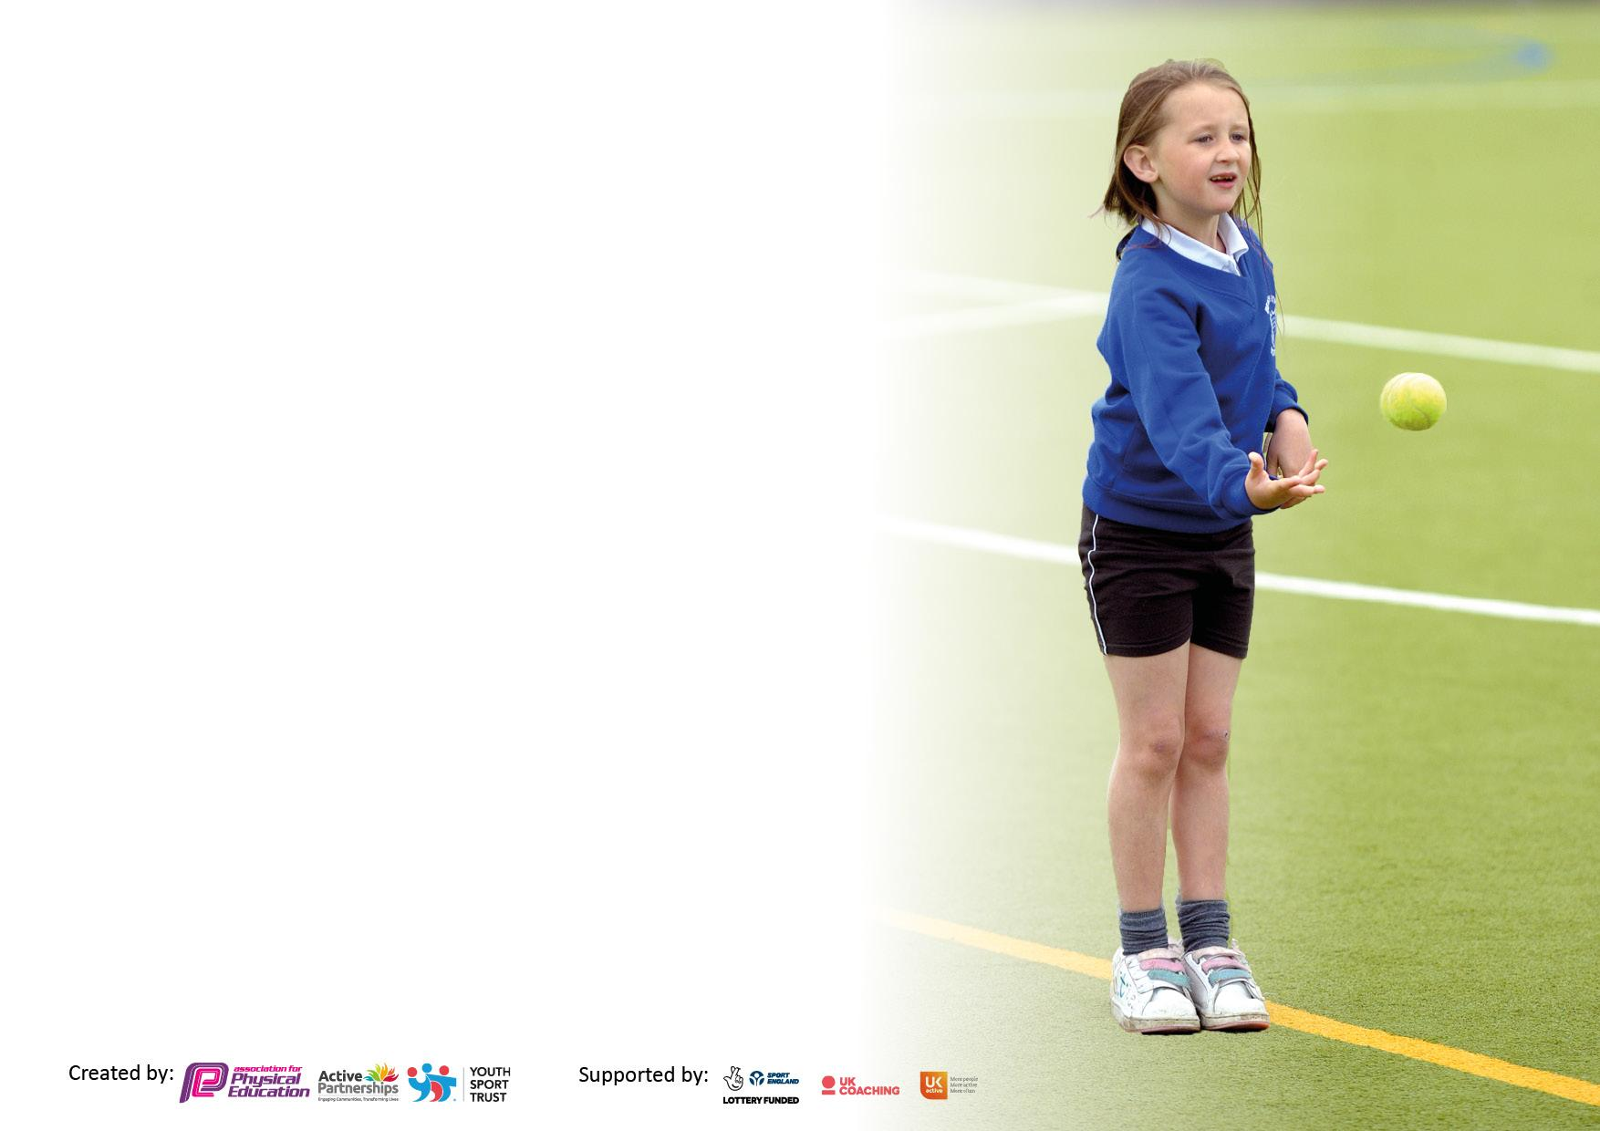

It is important that your grant is used effectively and based on school need. The Education Inspection Framework makes clear there will be a focus on ‘whether leaders and those responsible for governors all understand their respective roles and perform these in a way that enhances the effectiveness of the school’.

Under the Quality of Education judgement, Ofsted inspectors consider:
Intent - Curriculum design, coverage and appropriateness
Implementation - Curriculum delivery, teaching (pedagogy) and assessment
Impact - Attainment and progress

To assist schools with common transferable language, this template has been developed to utilise the same three headings which should make your plans easily transferable between working documents.

Schools must use the funding to make additional and sustainable improvements to the quality of Physical Education, School Sport and Physical Activity (PESSPA) they offer. This means that you should use the Primary PE and sport premium to:

- Develop or add to the PESSPA activities that your school already offers
- Build capacity and capability within the school to ensure that improvements made now will benefit pupils joining the school in future years
- The Primary PE and sport premium should not be used to fund capital spend projects; the school’s budget should fund these.

Please visit https://www.gov.uk/guidance/pe-and-sport-premium-for-primary-schools for the revised DfE guidance, including the 5 key indicators across which schools should demonstrate an improvement. This document will help you to review your provision and to report your spend. DfE encourages schools to use this template as an effective way of meeting the reporting requirements of the Primary PE and Sport Premium.

We recommend you start by reflecting on the impact of current provision and reviewing the previous spend.

Schools are required to publish details of how they spend this funding, including any underspend from 2021/2022, as well as on the impact it has on pupils’ PE and sport participation and attainment.

We recommend regularly updating the table and publishing it on your website throughout the year. This evidences your ongoing self-evaluation of how you are using the funding to secure maximum, sustainable impact. Final copy must be posted on your website by the end of the academic year and no later than the 31 July 2023.
Details with regard to funding
Please complete the table below.

Total amount carried over from 2021/22 | £0
Total amount allocated for 2022/23 | £19,560
How much (if any) do you intend to carry over from this total fund into 2023/24? | £ 0
Total amount allocated for 2022/23 | £ 19,560
Total amount of funding for 2022/23 to be reported on by 31st July 2023 | £ 19,560
Swimming Data
Please report on your Swimming Data below.

Meeting national curriculum requirements for swimming and water safety.

N.B. Complete this section as best you can. For example, you might have practised safe self-rescue techniques on dry land which you can then transfer to the pool when school swimming restarts.
Due to exceptional circumstances priority should be given to ensuring that pupils can perform safe self-rescue even if they do not fully meet the first two requirements of the NC programme of study
What percentage of your current Year 6 cohort swim competently, confidently and proficiently over a distance of at least 25 metres?  N.B. Even though your pupils may swim in another year, please report on their attainment on leaving primary school at the end of the summer term 2023.  Please see note above | 85%
What percentage of your current Year 6 cohort use a range of strokes effectively [for example, front crawl, backstroke and breaststroke]?  Please see note above | 85%
What percentage of your current Year 6 cohort perform safe self-rescue in different water-based situations? | 83%
Schools can choose to use the Primary PE and sport premium to provide additional provision for swimming, but this must be for activity over and above the national curriculum requirements. Have you used it in this way? | Yes/No  We have provided extra swimming lessons for those children who were not meeting the expected 25m standard.

Action Plan and Budget Tracking
Capture your intended annual spend against the 5 key indicators. Clarify the success criteria and evidence of impact that you intend to measure to evaluate for pupils today and for the future.

Academic Year: 2022/23 | Total fund allocated: £19,560 | Date Updated: June 2023
Key indicator 1: Increase confidence, knowledge and skills of all staff in teaching PE and sport |  |  |  | Percentage of total allocation:
 |  |  |  | 71%
Intent | Implementation |  | Impact
Your school focus should be clear on what you want the pupils to know and be able to do. What do they need to learn and to consolidate through practice: | Make sure your actions to achieve are linked to your intentions: | Funding allocated: | Evidence of impact:  What do pupils now know and what can they now do? What has changed? | Sustainability and suggested next steps:
Children develop a wide range of fundamental physical, personal and social skills. These skills will enable them to succeed in PE and sports activities and are transferable life skills. | Real PE whole staff training  Real PE Subject Leader Training  Supply cover | £ 595  £ 245  £60 | Real PE lessons are being delivered regularly and consistently across school. Children are making greater personal progress and levels of attainment are higher when progressing through each year and key stage. | Develop a more robust assessment framework as part of the Real PE curriculum.  Map the Real PE curriculum against other PE lessons ensuring that skills learned in Real PE lessons are reinforced in all PE lessons
Teachers create schemes of learning in PE based on lessons taught by coaches, follow-up meetings and discussion. | Coaches support the delivery of PE in KS1, KS2 and EYFS to help to  deliver a progressive scheme of work. Staff then implement | £11,000  £2,000 | Teachers have more confidence in delivering PE. They have been able to develop their own skills working alongside these coaches. Staff follow up these lessons in their second PE lesson each week. New schemes of learning are being planned. | Plans for the next academic year will ensure that coaches are used where there are gaps in staff knowledge and where PE lessons require a specialist to ensure that the quality of teaching and learning is of the highest standard. The Scheme of learning moving forward will look at the development of team sports to support and run alongside the Real PE scheme.
Key indicator 2: The engagement of all pupils in regular physical activity – Chief Medical Officers’ guidelines recommend that primary school pupils undertake at least 30 minutes of physical activity a day in school |  |  |  | Percentage of total allocation:
 |  |  |  | 4%
Intent | Implementation |  | Impact
Your school focus should be clear on what you want the pupils to know and be able to do. What do they need to learn and to consolidate through practice: | Make sure your actions to achieve are linked to your intentions: | Funding allocated: | Evidence of impact:  What do pupils now know and what can they now do? What has changed? | Sustainability and suggested next steps:
To provide a range of extracurricular clubs for children of all ages and abilities. | Clubs offered:  Multi skills  Y3/4 Football  Karate  KS2 Netball Club  Y5/6 Football  Swimming Club | 35 x 1 hour - 2 staff (£389 x 2)  Free places offered to specific children | These clubs have been offered throughout the year and have been attended by approximately 110 children. We have been able to target specific groups of children, encouraging attendance at these clubs. | These clubs will continue next year, and we are looking to increase the number of clubs offered to children as well as offering more diverse activities.
To train sports leaders in activities to keep children active. | FCA to train all Year 6 children | none. | This year the current Year 6 have had training with FCA. | A date is place for next year’s Year 6 to have their training.
Extra swimming lessons provided due to still catching pupils up with swimming from Covid closures. | Catch up lessons for identified children. Members of staff to support children in swimming lessons. | None – school budget funded. | To improve swimming across the school and to help those children/families who have missed out on early swimming lessons during Covid. | Progress is being made for all children with swimming and we are moving towards our previous standards of swimming.

Key indicator 3: The profile of PE and sport is raised across the school as a tool for whole school improvement |  |  |  | Percentage of total allocation:
 |  |  |  | 1.5%
Intent | Implementation |  | Impact
Your school focus should be clear on what you want the pupils to know and be able to do. What do they need to learn and to consolidate through practice: | Make sure your actions to achieve are linked to your intentions: | Funding allocated: | Evidence of impact:  What do pupils now know and what can they now do? What has  changed? | Sustainability and suggested next steps:
To raise the importance of fitness and the maintenance of an active, healthy lifestyle. | Children participate in the Daily Mile as often as possible across the year. | none | All year groups have been actively involved in the Daily Mile Challenge and enjoy competing with other classes and year groups. | The Daily Mile Challenge will continue next year. We are looking at other ways of recognising the achievements of children in this initiative.
Increase the importance of sport/ competition and physical activity. | Whole school participation in National Schools Sports Week. | none | Children experienced new activities requiring teamwork and resilience. Social skills, teamwork and developing sportsmanship were focus areas during the week.  House competition in KS2 to increase involvement from all children. | To offer different activities next year and use funding to involve external sports coaches that can offer taster sessions in more diverse sports/ activities.
To increase opportunities for children to participate in organised sports/ games during playtimes and lunchtimes. | Fifteen upper KS2 children completed formal leadership training in September 2022. | £200  (Part of the PE SLA agreement - £2500) | The Young Leaders assist with Key Stage 1 playtimes and are also responsible for distributing and tidying up equipment for Key Stage 2 playtimes and lunchtimes. This enables the school to provide a wider range of opportunities during unstructured times throughout the school day. | More KS2 children will access leadership training in the next academic year. This will ensure the number of leaders remains high enough for activities at play and lunchtimes.
To highlight the achievement of pupils in sport. | Assemblies to raise the profile of sport and sporting achievements.  Victor and Victrix Ludorum trophies to be presented to children at leavers performance.  Football awards to be given to Year 6 leavers for excellent attitude and team work.  Connor Brown award to be presented in school for attitude and ability in sport.  House trophy given for the most points in the summer sports. | £100 | Children are praised regularly in assemblies with medals and certificates earned throughout the year. This highlights the achievements of children but also reflects the need for resilience and an excellent attitude to all sporting activities.  Parents and other stakeholders are involved in these events raising the profile for all. | These awards will be carried out next year with a key focus on developing the summer sports and how this can be improved. The key focus needs to be participation for all and to work as part of a team.  Sports captains from Year 6 will support in the running of this.

Key indicator 4: Broader experience of a range of sports and physical activities offered to all pupils. |  |  |  | Percentage of total allocation:
 |  |  |  | 13.5%
Intent | Implementation |  | Impact
Your school focus should be clear on what you want the pupils to know and be able to do. What do they need to learn and to consolidate through practice: | Make sure your actions to achieve are linked to your intentions: | Funding allocated: | Evidence of impact:  What do pupils now know and what can they now do? What has  changed? | Sustainability and suggested next steps:
Every child has the opportunity to participate in at least one festival and one inter school competition throughout the year. | PE Service Level Agreement with Link Secondary School. This has provided opportunities for children across both key stages in:  trampolining, mini athletics, tri golf, quad kids athletics, dance and swimming. | £1,150  (This is part of the £2,500 total) | An extensive programme of events has resulted in a vast number of opportunities for children across the school. Children have competed in festivals, intra school and inter school competitions at East Herrington as well as at outside venues. | Signing up to the PE SLA next year, will enable children to participate in even more sporting opportunities. This further increases the profile of sport and PE
All Year 5 children have access to 2 hours of coaching from Newcastle Eagles Basketball Club and play in competitive basketball fixtures. | Sign up to the Hoops 4 Health Basketball programme. | £500  £380 (transport) | All children took part in a basketball tournament against other schools at the Newcastle Eagles home arena. The children really enjoyed this experience, and it was their first time playing competitive basketball matches against other schools. | Due to the successful outcomes of this programme, we have already signed up to the programme for next year.
Transport to sporting events such as local events and residential offering adventurous sporting activities. | For children in Year 5 and 6 to attend adventurous sports providers. | £600 | All children were able to take part in new adventurous sporting events building resilience and confidence. | All of the events were highly beneficial in preparing children for future challenges and provided children with a number of new experiences

Key indicator 5: Increased participation in competitive sport |  |  |  | Percentage of total allocation:
 |  |  |  | 10%
Intent | Implementation |  | Impact
Your school focus should be clear on what you want the pupils to know and be able to do. What do they need to learn and to consolidate through practice: | Make sure your actions to achieve are linked to your intentions: | Funding allocated: | Evidence of impact:  What do pupils now know and what can they now do? What has  changed? | Sustainability and suggested next steps:
Experience high level competitive swimming opportunities. | Children form Year 5 and 6 competed in the Sunderland Schools Swimming Gala at Sunderland’s Aquatics Centre | £180 | Children gained great success in this winning and placing in a number of events. Medals were won and the children had a fantastic time, experiencing competitive swimming at a top-class venue. The children’s confidence in their own swimming ability has increased as a result of their success at this event and the year 5 children are keen to compete again next year. | This event will be entered again next year, and our elite swimmers will be offered additional swimming lessons before school as part of our SLA agreement.
Experience competitive sports opportunities against other schools, developing leadership, teamwork and social skills. | Transport to events:  Tennis coaching followed up with Tennis tournament at the Sunderland Tennis Centre (Year 3)  Dodgeball tournament at the Sunderland Tennis Centre (Year 4)  Sunderland Schools Triathlon (year 5 and 6 children) | £84 (coaching)  £478 (transport) | All of these events were highly beneficial in giving new opportunities that many had not previously experienced. Children’s resilience, self-confidence and self-esteem has improved due to success in these competitions as well as helping them develop their ability to deal with not succeeding. | All of these events will be entered once again next year if they are offered by our partner secondary school as part of the SLA agreement.
Experience competitive sports opportunities against other schools, developing leadership, teamwork and social skills. | Y3 Quadkids Athletics  Y4 Rounders  Y5 Hockey  Y5 Kwik Cricket  Y5/6 Feeder Schools Games Swimming Gala  Y6 Quadkids Athletics | £1,150  (This is part of the £2,500 total
Experience competitive sports opportunities against other schools, developing leadership, teamwork and social skills. | Affiliation to and involvement in league and cup competitions in the Sunderland Schools Primary Football Leagues. A and B teams were entered into competitions. | £60 |  | We will affiliate to the Sunderland Schools League again next year.
Key achievements to date: |  | Areas for further improvement and baseline evidence of need:
- All children to receive 2 hours of PE teaching per week  - KS2, KS1, EYFS coach to up-skill staff  - Continuation of REAL PE in Years 1 - 6  - Platinum award maintained in School Games Mark  - Gold award maintained in the School Games Charter  - Participation in the National Daily Mile  - Year 5 children participating in the Hoops 4 Health programme  - Bikeability offered to all Year 5 children  - Year 5 and 6 both attended an adventurous outdoor sports residential trip  - Opal play offer at playtimes and lunchtimes supports the PE and outdoor curriculum – the school has achieved silver award.  - Forest school has been implemented to further develop the outside curriculum – all children have access to this provision.  - New football league attended – Sunderland schools league.  - Swimming results and progress are improving across KS2 |  | - To ensure that REAL PE is introduced to new members of staff and that this is planned alongside a team sports curriculum to further develop the PE offer at EHPA  - Continue to access Opal areas - children to have more choice of physical activities.  - Continue to access forest school and ensure that it is mapped to the curriculum and skills are progressive and sequenced.  - Continue to target specific groups when planning swimming lessons in order to meet National expectations by the time children leave Year 6.  - Continued investment in high quality PE resources to provide more opportunities across all areas of Sport  - Change for Life club to continue with support of Year 6 sport leaders  - Continue to work with Dance City to promote dance with targeted groups  - More coaches to support areas of the curriculum needed for CPD e.g. dance and gymnastics.  - Continue to develop and support extra-curricular clubs and variety of these allowing as many children as possible to access these.

Signed off by
Head Teacher: | Nicola Hair
Date: | July 2023
Subject Leader: | Mr. K Newton
Date: | July 2023
Governor: | Simon Snowdon
Date: | July 2023

